**LAB ACTIVITY**

**PENGOLAHAN CITRA DIGITAL**

**Pertemuan 3 – Load Video**

|  |  |
| --- | --- |
| Nama: Muhammad Rifqi Amir Putra | NPM: 062230701416 |
| Kelas: 5 CA | Mata Kuliah: Pengolahan Citra Digital |

**Alat dan Bahan:**

1. Text Editor
2. Python
3. Library Python OpenCV
4. Google Colab (Opsional)
5. Video
6. Kamera / Webcam
7. **Load Video dari File**

Source Code:

**import cv2 as cv**

**cap = cv.VideoCapture("Gambar/estetik-video-resize-854x480.mp4")**

**while True:**

**ret, frame = cap.read()**

**if not ret:**

**print("Video sudah selesai diputar.")**

**break**

**cv.imshow("Muhammad Rifqi Amir Putra", frame)**

**key = cv.waitKey(10)**

**if key == 27 or key == ord('q'):**

**break**

**cap.release()**

**cv.destroyAllWindows()**

Hasil:

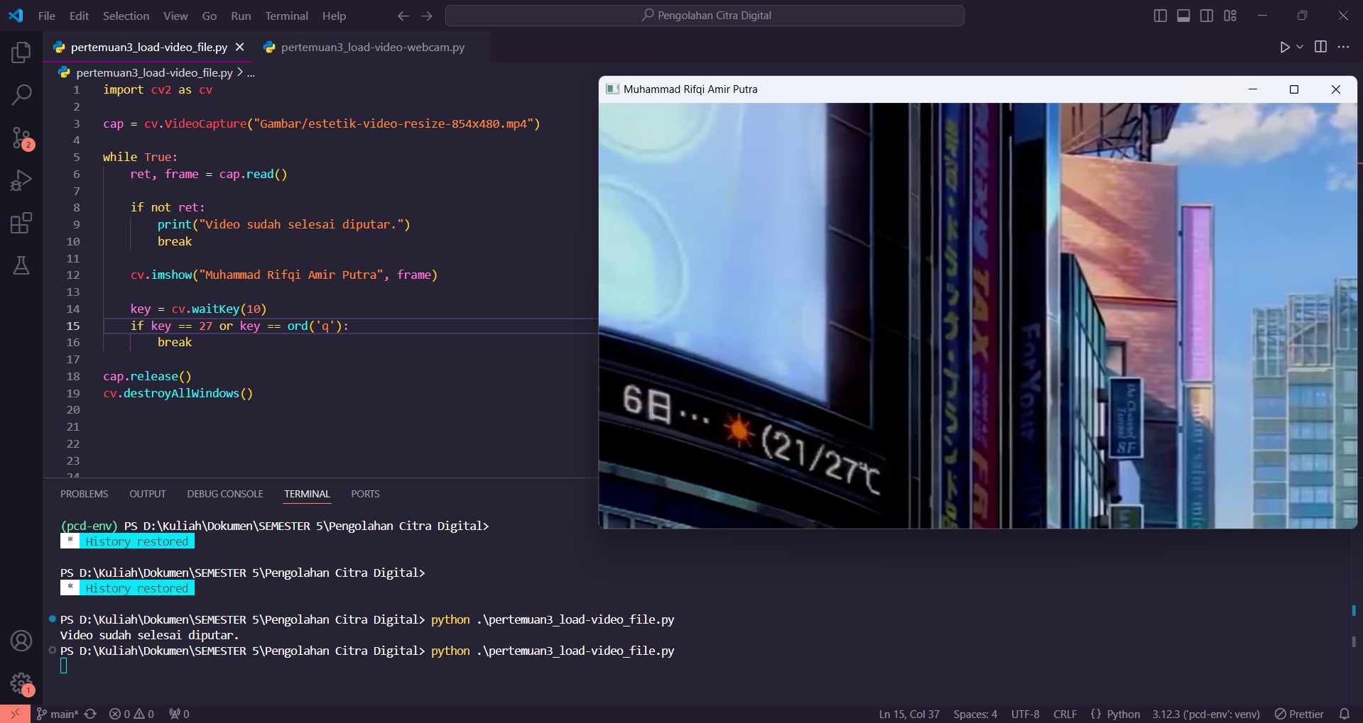

1. **Load Video dari Kamera atau Webcam**

Source code:

**import cv2 as cv**

**cap = cv.VideoCapture(0)**

**while True:**

**ret, frame = cap.read()**

**cv.imshow("Muhammad Rifqi Amir Putra" ,frame)**

**key = cv.waitKey(1)**

**if key == 27 or key == ord('q'):**

**break**

**cap.release()**

**cv.destroyAllWindows()**

Hasil:

